Assignement 1 : Text Feature Engineering Assignment (Real-world Dataset)

Task 1: Preprocessing
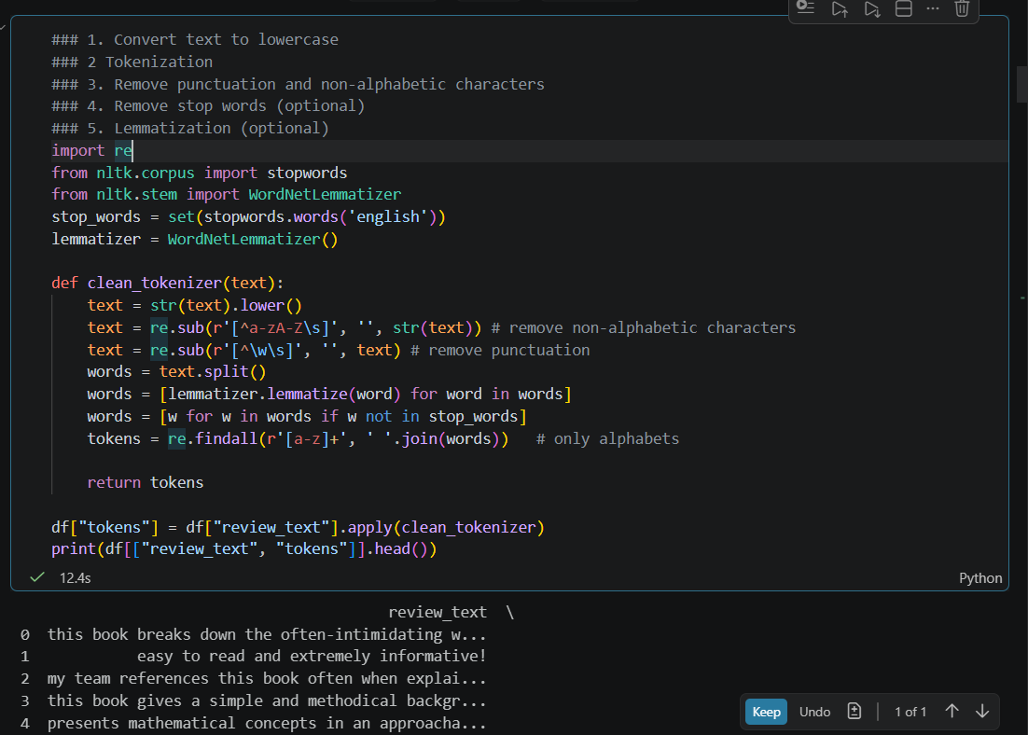

Task 2: Vocabulary Creation
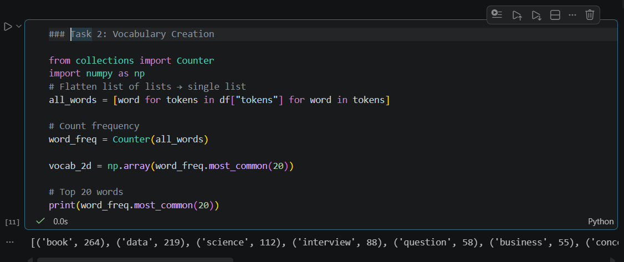

Task 3: Feature Engineering
One Hot Encoding (document-level vector)
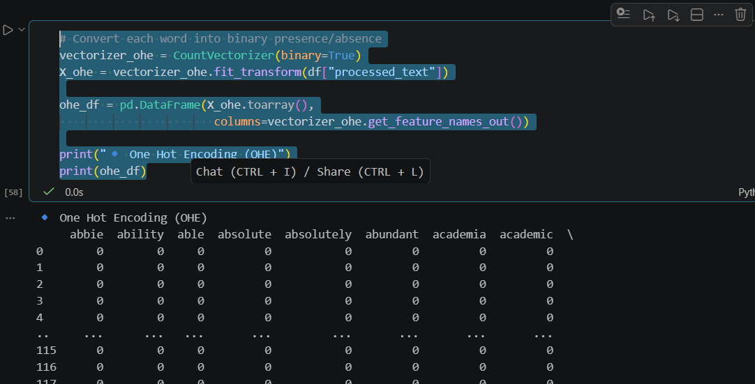
Bag of Words using CountVectorizer
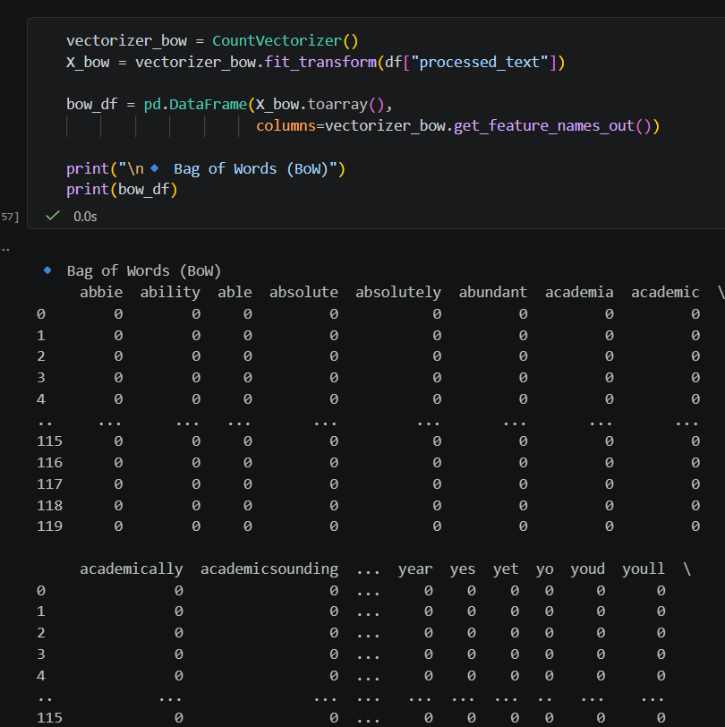

TF-IDF using TfidfVectorizer
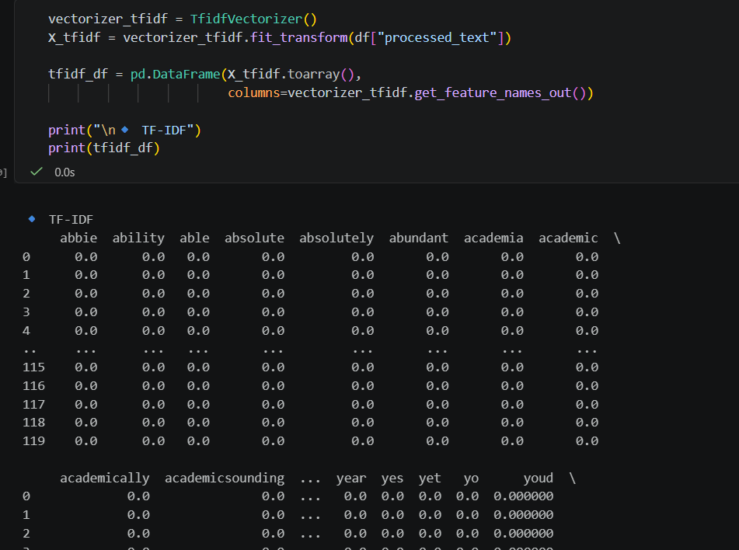

Task 4: Comparison Analysis
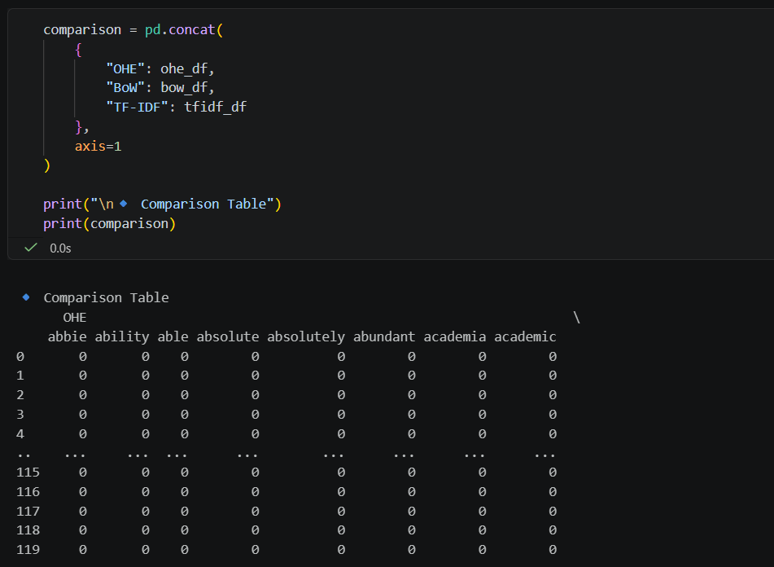
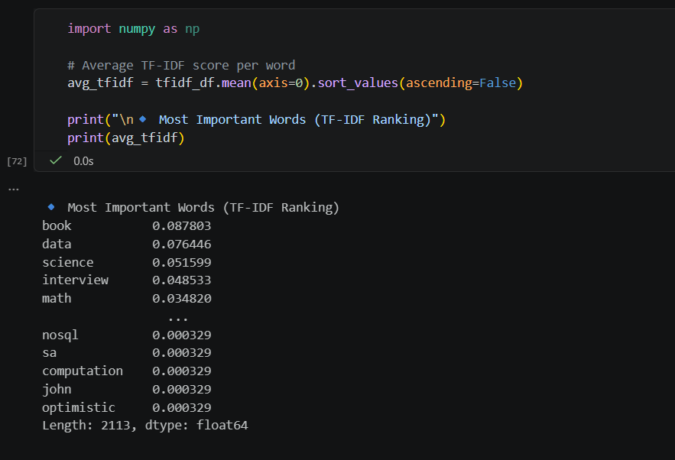
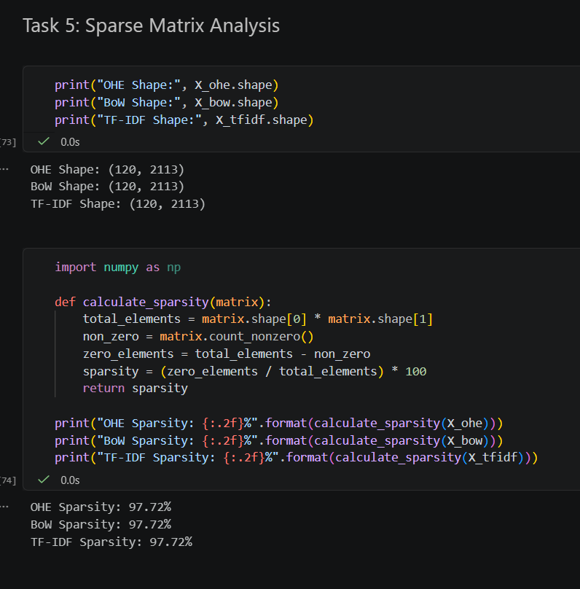
Task 6: Real-world Questions
1 Why Bag of Words fails in understanding semantic meaning (example: similar meaning words)
- Bag of Words (BoW) treats each word as an independent token and ignores context or relationships between words.
- cannot recognize that words like “good” and “excellent” have similar meanings because they are represented as completely different features.
- BoW also ignores word order, so sentences like “not good” and “good” may look similar.
As a result, it fails to capture semantic meaning and deeper language understanding.
2 When to use Bag of Words and TF-IDF in industry
- Use Bag of Words (BoW) when you need a simple, fast baseline or when word frequency alone is sufficient, such as basic text classification or keyword matching.
- BoW works well on smaller datasets and when interpretability is important.
Use TF-IDF when you want to reduce the impact of common words and highlight more informative terms.
- TF-IDF is preferred for tasks like search, document ranking, and sentiment analysis where word importance matters.
In practice, TF-IDF is often chosen over BoW for better performance with minimal added complexity.

- Limitations of TF-IDF in real applications
- TF-IDF does not capture semantic meaning, so it treats similar words like “good” and “excellent” as unrelated.
- It ignores word order and context, making it weak for understanding phrases like “not good.”
- It creates high-dimensional sparse vectors, which can be inefficient for large-scale systems.
- It also cannot adapt to language nuances like sarcasm or domain-specific meanings

Task 7: Mini Use Case
# Perform sentiment classification (positive vs negative reviews)
